**Shadow Stalk: Forsaken Hospital**

**Designer: Patrick McComber**

**01/28/2021**

**Table of contents**

Overview................................................................................................................. 3

Location & Environment............................................................................... 3

Level Assets................................................................................................. 3

Change Log............................................................................................................. 4

Level Intent……....................................................................................................... 4

Map Layout……....................................................................................................... 5

Area Breakdown....................................................................................................... 5-11

Pacing Chart…......................................................................................................... 12

**Overview**

**Level Location and Environment**

* Indoors
* Dark, Gloomy, Ominous
* Hospital Setting/Aesthetic

**Level Assets**

**Characters**

* Shades (Player Controlled)
* Mist Walker (Player Controlled)

**Pickups**

* Keys
* Healing Item
* Monster Stun Item

**Obstacles**

* Shade Stun Trap
* Shade Escape Utility
* Route Blocker

**Change Log**

**02/14/2021**

* Removed possible exit from Area 3
  + Felt that this exit served little purpose, as there was an exit directly beside it.
* Updated Room interiors to be more detailed.
* Specified locations of various spawns.
* Fixed error stating that there was a broken wall in Area 15 granting access to Area 17
  + This was actually intended to be in Area 14.
* Removed key spawn from Area 2.
  + Felt that two keys in such close proximity was unnecessary and too easy.
* Fixed error stating that there was a potential exit at the eastern side of Area 19
  + The exit is actually on the western wall.

**Level Intent**

* Due to the nature of the game we intend to create, the level for Shadow Stalk is designed to be very non-linear, and instead aims to allow a higher amount of dynamism.
* The level will have randomized spawns of various items, meaning that it is not a level that can be memorized and beaten progressively faster. Each time playing will be unique, and thus more engaging.
* As the match progresses, the difficulty will naturally increase as well, as the Mist Walker deploys more traps, alternate pathways are closed, utilities are expended, and the number of Shades decreases.
* We intend for the matches to take 10-20 minutes at most to complete.

**Map Layout**

*Please view* ***ShadowStalk_ForsakenHospital.pdf*** *for map layout.*

**Area Breakdown**

**Area 1 - Main Lobby**

● This room is large and open. Benches and decorative plants, now wilted, ring the walls along the exterior of the room. There is a large amount of rubble and damage scattered across the ground, often directly underneath holes in the roof. This in turn makes the terrain difficult to navigate.

● A “receptionist” desk sits in the center of the room, providing some additional cover for the room. A key can spawn on the inner part of the desk, meaning a player would need to “trap” themselves temporarily to access it.

● At the south of this room is the “Front Entrance” of the hospital, which is also a possible escape at the end of a match.

**Area 2 - Waiting Room**

● A smaller and simpler room, this waiting room is mostly occupied by benches and chairs, although in as much disarray as the Main Lobby.

**Area 3 - Ambulance Garage**

● Where ambulances come and go, this room is mostly bare aside from the two ambulances sitting in front of the two garage doors.

● This area is a potential spawn point for a consumable item, which would be positioned near the back of the ambulance farthest from the door.

**Area 4 - Storage Room**

● A smaller room intended for the storage of various supplies and hospital items. Shelves all throughout the room have various clutter among them, making seeing through the shelves difficult.

**Area 5 - Small Nursing Station**

● In between two surgery rooms, this area is a quick restocking area for doctors using either of the rooms. It consists of a long countertop covering all 3 walls of the area.

● A consumable item can spawn on top of the countertop along the eastern wall.

**Area 6 - Surgery Prep Room 1**

● A room for preparing patients to undergo surgery. The room is mostly empty except for the curtain that encircles a large part of the center of the room, and a countertop on the northern wall. Various medical tools lay around, acting as potential noise makers if a Shade is not careful.

● There is a potential Shade spawn point in the South-Eastern corner of the room.

**Area 7 - Surgery Prep Room 2**

● Same as Area 6, however there is no Shade spawn point, and the countertop is on the southern wall.

● This area can instead have a key spawn on the countertop.

**Area 8 - Patient Waiting Room**

● An area for visitors to wait for news about procedures. Much like Area 2, however more focused on comfort (ie: Sofas and Lounge Chairs instead of benches). This in turn means it’s easier for Shades to hide in this room.

● The hallway outside this room has two route blockers, where the Mist Walker can permanently block one end of the hallway.

● An item can spawn in the center of this room, on a sofa/couch. This in turn means the Shade has to get in the thick of the room to grab the item.

**Area 9 - Chapel**

● A medium sized chapel for people to pray. Composed of a few rows of pews and a podium on the western side of the room, Shades can utilize their small size to hide among the pews.

● A Shade can potentially spawn in front of the podium.

**Area 10 - Surgery Room 1**

● This room consists of a central surgery table, surrounded by medical equipment and electronics. A large, moveable ceiling light illuminates the table, and various medical instruments lay around the room, acting as potential noise makers.

● A Shade can potentially spawn beside the surgery table.

● In the hallway to the south are two route blockers, which the Mist Walker can use to block one end of the hallway.

**Area 11 - Surgery Room 2**

● Same as Area 10, except instead of being a potential Shade spawn point, it is instead a potential key or consumable item spawn point.

● Either a key or a consumable item can spawn on the surgery table, but not both.

**Area 12 - Non-Emergency Waiting Room**

● A smaller waiting room than Area 2, however similarly designed. A collection of benches and chairs where people would wait to get looked at.

● A consumable item can potentially spawn on a chair in the east side of the room.

● This area also has a potential exit at the north-western side.

**Area 13 - Registration/Admin**

● Mainly dominated by a large reception area, this area is where people would get checked into or out of the hospital.

● Similar in decoration to Area 1, the room is ringed in seating and decorative plants. However, there is a large reception desk situated against the southern wall. It can be used as cover by the shades, whilst also presenting an obstacle for those who enter from Area 14.

**Area 14 - Nursing Station**

● This nursing station is home to two large cracks in the floor, which lead to Area 24. This presents a challenge for Shades if they wish to quickly cross the room, or access the center platform.

● The “island” in the middle is a cluttered mess, with the remains of shelves and medical storage units scattered across it.

● This room, due to the challenge, is both a potential key spawn and a potential consumable item spawn. The key can spawn in an organ cooler near the north side of the “island”, whilst the consumable can spawn on a knocked over shelf close to the southern wall of the “island”.

● The western wall of this room is broken down, granting access to Area 17

**Area 15 - Pharmacy**

● A drugstore within the hospital, laid out like your average drugstore. A few rows of shelves, as well as an over the counter area to fill your prescriptions.

● A shade can potentially spawn behind the counter at the south side of the shop.

● A consumable item can potentially spawn on the shelves near the western side of the wall.

**Area 16 - Janitor’s Closet**

● A small cramped closet, Shades could make use of this to temporarily hide from the Mist Walker.

**Area 17 - Cafeteria**

● A very large open room, designed like a traditional cafeteria. Large, long tables in rows throughout the rooms, with chairs scattered around. Due to the nature of the room, navigation through it can be challenging due to the clutter.

● The eastern wall of this room is broken down, granting access to Area 14.

● The northern side of the room is partially blocked by a counter.

**Area 18 - Kitchen**

● A somewhat cramped kitchen, cluttered with noise making utensils and objects.

● Due to the danger of this room only having one entrance/exit, and the potential to make a large amount of noise in it, this area is both a potential key spawn and a potential consumable item spawn.

● The key can spawn inside a pot on a stove against the eastern wall, while the consumable can spawn on the floor near the entrance of the room.

**Area 19 - Visitor Check In**

● An area for visitors to check in before visiting a patient, this room is designed similarly to Area 1. Rubble is scattered throughout the room, which is ringed in wilted plants and benches. In the center of the room is an administration desk.

● There is a potential exit on the western wall of the area.

**Area 20 - Patient Recovery North**

● An entire wing of patient suites, for recovering patients. A collection of 8 rooms total.

● The description of each room can be found in Area 22 and 23.

● Due to the size, this wing has a potential Shade spawn point as well as a potential consumable item spawn.

● The Shade spawn point is beside the western bed in the top left room.

● The consumable item spawn point is on top of the eastern bed in the second room on the right.

**Area 21 - Patient Recovery South**

● Identical to Area 20, except with an additional potential key spawn.

● The Shade spawn point is in the bathroom of the first room on the left.

● The consumable item spawn is under the western bed of the third room on the right.

● The key can spawn in the toilet of the last room on the right.

**Area 22 - Patient Room**

● A simple room composed of two patient beds, with some medical machinery beside them and curtains to be pulled across for privacy.

**Area 23 - Patient Bathroom**

● As simple as Area 22, the bathroom is composed of a sink, toilet, and small shower. It is possible for Shades to hide in the shower.

**Area 24 - Morgue**

● This room is deeply corrupted, making it much darker and foggier than normal. A few tables sit side by side, where cadavers would be placed. The southern wall is where bodies are stored.

● The Mist Walker spawns in the center of this room, amidst the tables.

● Due to the increased threat of this room, it is a possible spawn point for both a key and a consumable item.

● The key can spawn in the south-western corner, in an open body storage cubby.

● The consumable item can spawn on one of the central tables.

**Area 25 - Maintenance**

● A cramped room that contains a large collection of maintenance related tech. Servers, power switches, and machinery result in this room having only a single path through it.

● A consumable item can potentially spawn at the western side of the room, on a server rack.

**Area 26 - Laundry Room**

● A room containing a wall of washers and dryers. Piles of clothes lay around the room, with laundry carts scattered throughout. Various cloths lay hanging up, granting Shades that enter this room a stronger potential of escaping the Mist Walker.

**Area 27 - Maintenance Office**

● An office for the maintenance workers, it consists of a small break area and a desk in the northeastern corner.

● The break area is composed of a few chairs and a table, along with a counter. The desk area is simply a desk with a chair.

● Due to the simplicity of the room meaning Shades do not have many options to hide, as well as there only being one entrance in such close proximity to Area 24, this area is a potential spawn point for both a key and a consumable item.

● The key can spawn on the desk.

● The consumable item can spawn on the counter along the southern wall.

**Area 28 - Elevators and Stairwells**

● A row of elevators, as well as a stairwell. The elevators are broken, meaning the stairwell is the only option

● The stairwell is a potential route blocker, as the Mist Walker can destroy one stairwell, blocking its use.

**Pacing Chart**

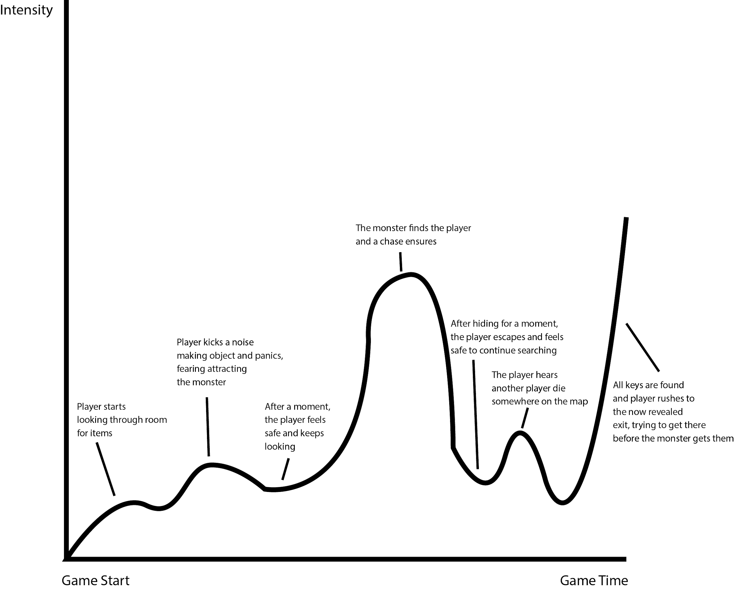

Due to the dynamic nature of our game, the pacing chart can vary wildly. Here is an example of a pacing chart for one match.